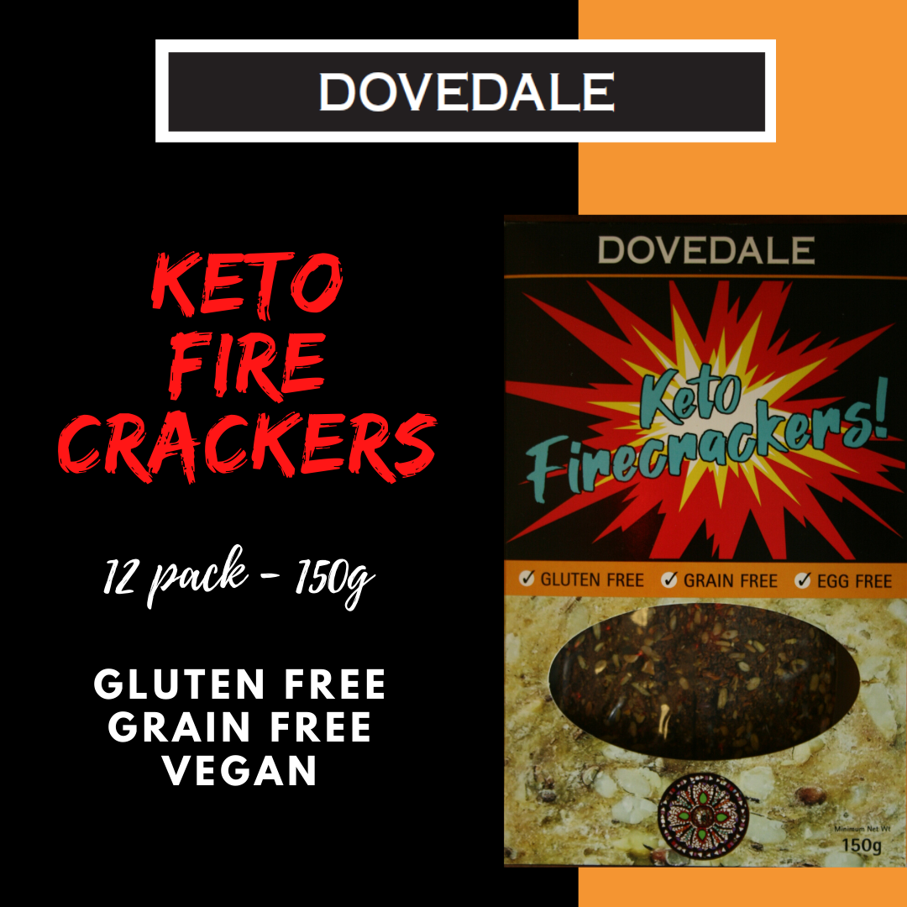
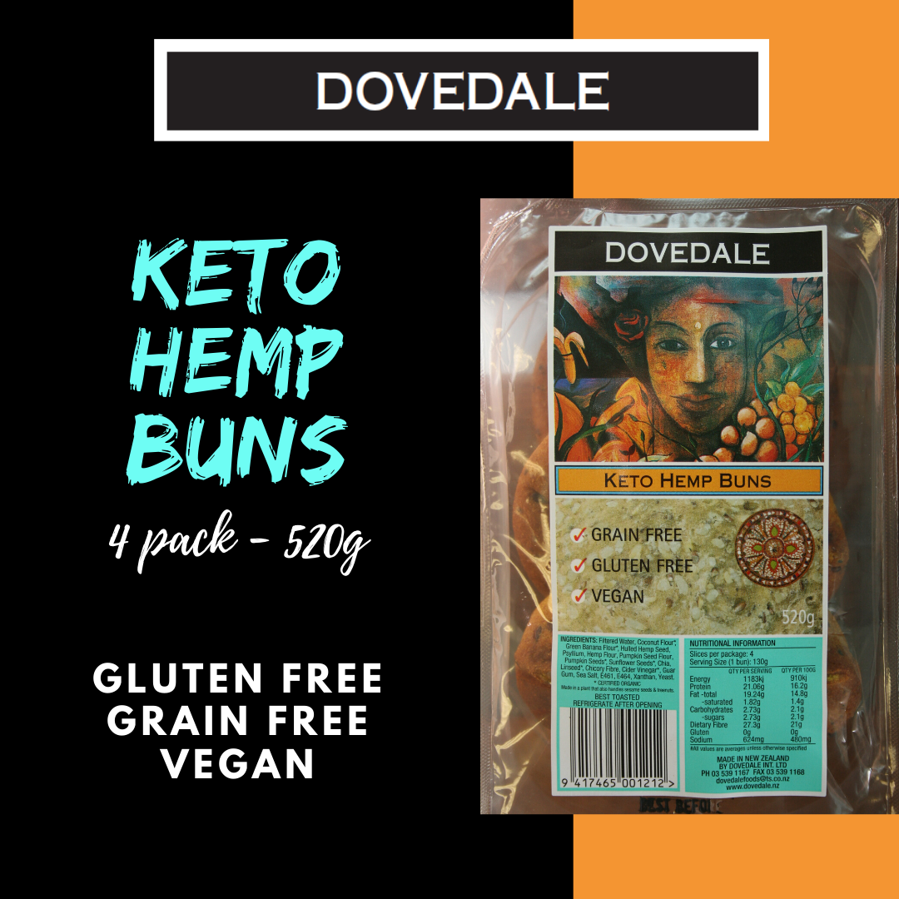
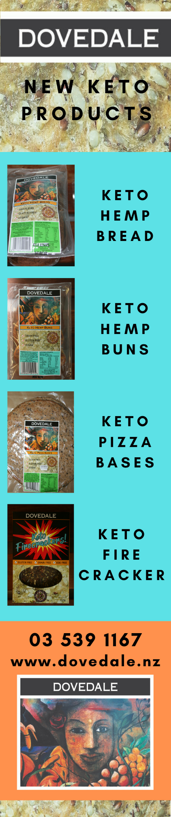

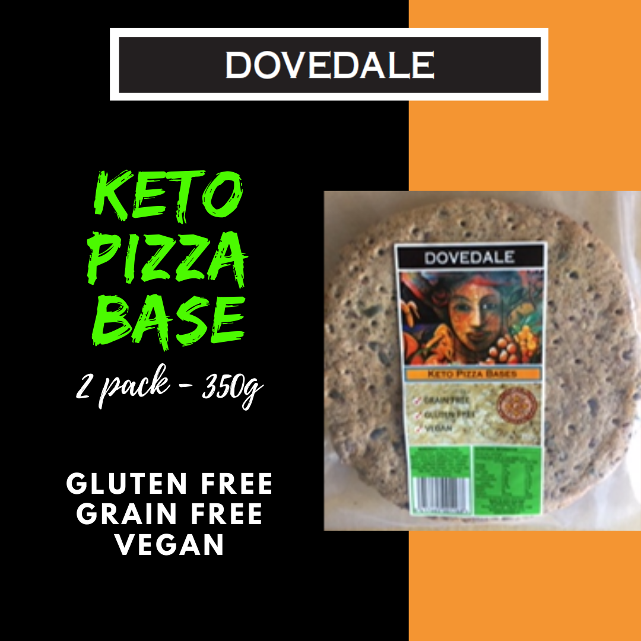
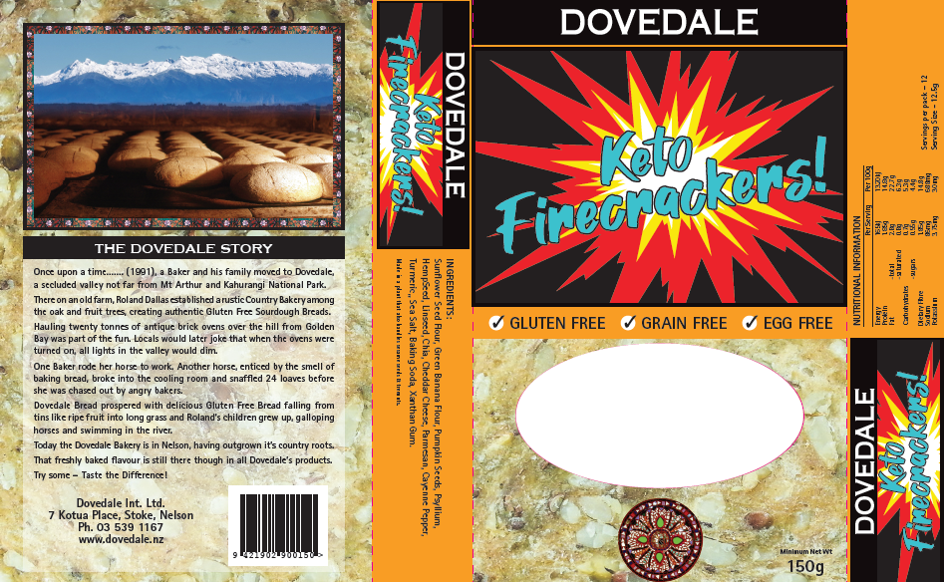
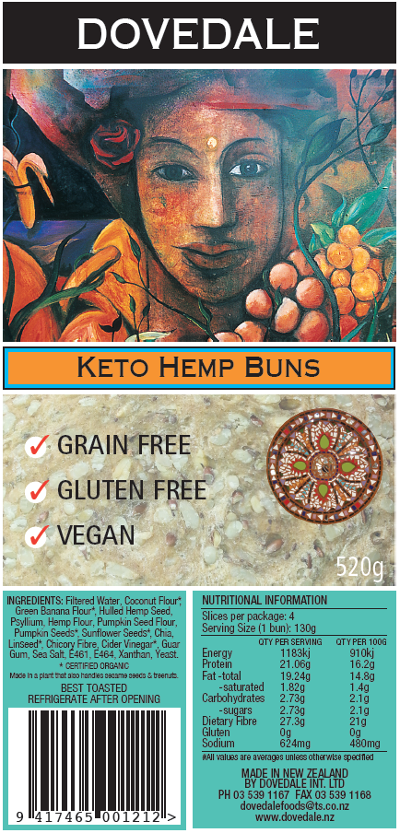

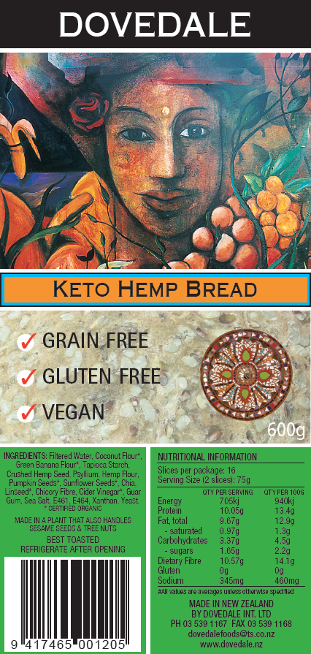
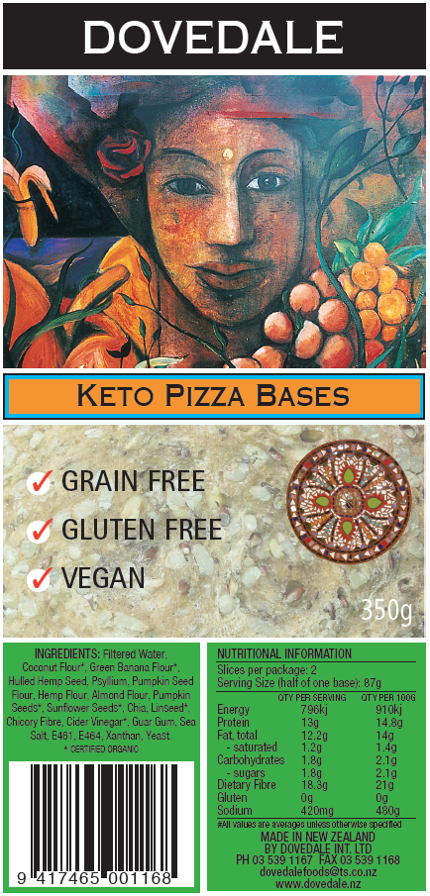
Keto Hemp Bread
Nutritional Info :slices per package- 16
Serving Size –( 2 slices) 75g
Quantity per Serving Qty per 100
Energy 705kj 940kj
Protein 10.05g 13.4g
Fat-total 9.67g 12.9g
-saturated .97g 1.3g
Carbohydrate 3.37g 4.5g
-sugars 1.65g 2.2g
Dietary Fibre 10.57g 14.1g
Gluten 0 0
Sodium 345mg 460mg

KETO HEMP BUNS – 520g
Buns per Package -4
Serving Size( one bun) 130g
Per serving per 100g
Energy 1183kj 910kj
Protein 21.06g 16.2g
Fat -Total 19.24g 14.8g
-saturated 1.82g 1.4g
Carbohydrates 2.73g 2.1g
-sugars 2.73g 2.1g
Dietary Fibre 27.3g 21g
Gluten 0g 0g
Sodium 624mg 480mg

KETO FIRECRACKERS 150g:
Servings per pack – 12 Serving Size 12.5g
Quantity per Serving Quantity per 100g
Energy 165kj 1320kj
Protein 1.85g 14.8g
Fat-total 2.8g 22.7g
-saturated .8g 6.3g
Carbohydrates .7g 5.3g
-sugars .55g 4.4g
Dietary Fibre 1.85g 14.8g
Sodium 86mg 688mg
Potassium 3.75mg 30mg
Barcode : 9 421902 900150
PIZZA BASES
Bases per package : 2
Serving Size : half of one base 87g
Quantity per Serving Quantity per 100g
Energy 796kj 910kj
Protein 13g 14.8g
Fat- total 12.2g 14g
-saturated 1.2g 1.4g
Carbohydrate 1.8g 2.1g
-sugars 1.8g 2.1g
Fibre 18.3g 21g
Sodium 420mg 480mg
Gluten 0g 0g
#all values are averages unless otherwise specified

Keto Hemp Bread 600gm
Gluten Free, Grain Free, Vegan
INGREDIENTS: Filtered Water, Coconut Flour*, Green Banana Flour*, Hulled Hemp Seed, Psyllium, Hemp Flour, Pumpkin Seed Flour, Pumpkin Seeds*, Sunflower Seeds*, Chia, Linseed*, Chicory Fibre, Cider Vinegar*, Guar Gum, Sea Salt, E461, E464, Xanthan, Yeast.
* CERTIFIED ORGANIC
Shelf Life: 4 weeks
Keto Hemp Buns (4 pack) 520gm
Gluten Free, Grain Free, Vegan
INGREDIENTS: Filtered Water, Coconut Flour*, Green Banana Flour*, Hulled Hemp Seed, Psyllium, Hemp Flour, Pumpkin Seed Flour, Pumpkin Seeds*, Sunflower Seeds*, Chia, Linseed*, Chicory Fibre, Cider Vinegar*, Guar Gum, Sea Salt, E461, E464, Xanthan, Yeast.
* CERTIFIED ORGANIC
Shelf Life: 4 weeks
Keto Pizza Bases (2 pack) 350gm
Gluten Free, Grain Free, Vegan
INGREDIENTS: Filtered Water, Coconut Flour*, Banana Flour*, Hulled Hemp Seed, Psyllium, Hazelnut Flour, Hemp Flour, Almond Flour, Pumpkin Seeds*, Sunflower Seeds*, Chia, Linseed*, Chicory Fibre, Cider Vinegar*, Guar Gum, Sea Salt, E461, E464, Xanthan, Yeast.
* CERTIFIED ORGANIC
Shelf Life: 3 weeks
Keto Firecrackers 150gm
Gluten Free, Grain Free,
INGREDIENTS: Sunflower Seed Flour, Green Banana Flour, Pumpkin Seeds, Psyllium, Hemp Seed, Hemp Flour, Linseed, Chia, Cheddar Cheese, Parmesan, Cayenne Pepper, Turmeric,, Sea Salt, Baking Soda, Xanthan Gum.
* CERTIFIED ORGANIC
Shelf Life: one year

